AI Fitness Analyst

The AI Fitness Analyst is a modern web application built with React and Tailwind CSS that utilizes the Groq API to generate tailored fitness plans and provide real-time coaching advice based on user profiles.

**Personalized Profile:** Capture essential fitness metrics (Age, Gender, Height, Weight, Goals, Equipment).

**BMI Calculation:**Automatic calculation and display of Body Mass Index. **AI-Powered Plan Generation:** Generates a structured workout plan (Warm-up, Strength, Cardio, Cooldown)

**Predicted timeline:** to reach the target weight, all within a constrained JSON format.

**AI Fitness Chatbot:**A friendly, context-aware chatbot for real-time fitness, nutrition, and workout advice, maintaining a strict on-topic policy. **Responsive UI:** A modern, dark-themed, and responsive user interface built with **Tailwind CSS,Robust API Handling**: Uses a `fetchWithRetry` utility for reliable API calls

Setup & Installation

1. Node.js
2. Install Dependencies (npm install)
3. Configure API Key

('[https://api.groq.com/openai/v1/chat/completions](https://api.groq.com/openai/v1/chat/completions)';

1. Run the Application (npm run dev)

Tech Stack

1. React
2. Tailwind css
3. Llm - groq
4. API handling

Predictive Logic

1. **BMI Calculation (Client-Side Logic)**

The **Body Mass Index (BMI)** is calculated directly in the client-side JavaScript using the utility function:

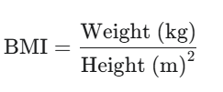

The calculated BMI and the user's profile are then passed to the AI to inform its plan generation.

1. **Logic Behind Predicted Time**

### 1. Identify Goal & Total Change

The AI first looks at your **Total Weight Differenc**

### 2. Set the Base Weekly Rate

The model uses established, **safe weekly rates** as a starting point:

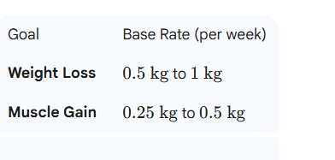

### 3. Personalize the Rate (The AI Adjustment)

The AI then fine-tunes this rate based on your profile to make it realistic:

**Faster Rate:** If you have a **high BMI** and an **Active** lifestyle.

**Slower Rate:** If you have a **lower BMI** or a **Sedentary** lifestyle, or if your equipment is limited (for muscle gain).

### 4. Calculate Time

Finally, it performs a simple division using the chosen, personalized rate:

.

